TPMGC Player Selection System
Developer’s Guide
Version 1.0

The TPMGC Player Selection System, referred to as “PSS” throughout the remainder of this documentation, is a Microsoft Excel based tool built using formulas, named ranged, pivot tables and custom Visual Basic coding. The tool requires Microsoft Excel version 2013 or later. The file is setup in logical order to pass information that is input into the tool through a series of steps that apply business rules to rank individual members and then teams in order of their adjusted priority scores. The Visual Basic Forms and Modules group related macros for specific functions and all macros include comments within the coding to describe their intended functionality.
For reference, if needed, all passwords (VBA Project and Worksheets) for the tool are “jEconsulting”.
The PSS file contains numerous worksheets to process the information. For usability and functionality purposes, these are hidden from the User. However, these worksheets can be unhidden by running a macro.
To unhide all hidden worksheets, perform the following steps:

- Open the Visual Basic Editor (for quick access, press and hold Alt + F11 when in Excel)

- Double-click on the list item with the PSS file name on the left
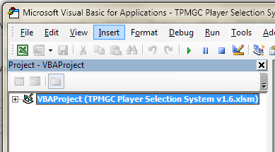

- Enter password in the VBAProject Password prompt and click OK (Note: Password is “jEconsulting”)

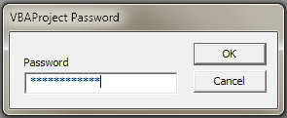

- Click ‘+’ to expand the Modules list
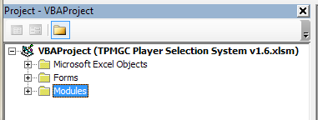

- Double-click on ‘mcr 1_settings’
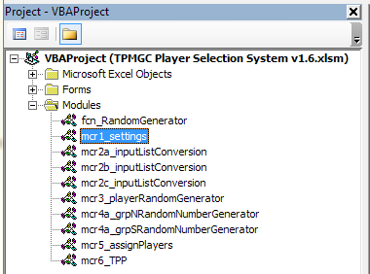

- Click inside ‘ShowDataSheets’ macro in the Code Window to the right, then press the play button in menu bar. This will unhide all hidden worksheets in the file

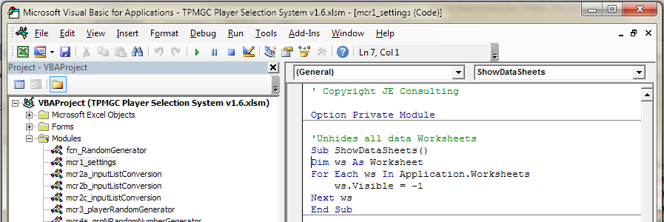

- Close or hide the VBA Editor and navigate back to the PSS Excel file to see the additional worksheets located at the bottom of the screen

Forms Overview

- frmAssignPriority
Description: Contains the Priority Assignment Userform and related macros to properly execute its functionality.

Purpose: Used to manage players that are selected for privileged groups: Board Members, Honorary, Special Volunteer and Guest. Players selected for these groups are assigned priority scores as defined in the Priority Score Management Userform.

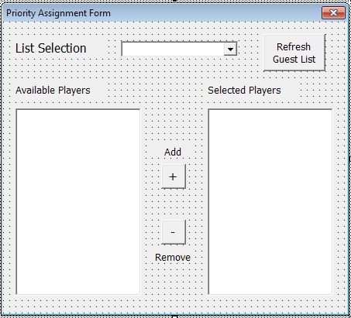

- frmCalendar
Description: Contains the Calendar Userform and related macros to properly execute its functionality.

Purpose: Used as a date selector for the event date entered in the Event Information Userform.

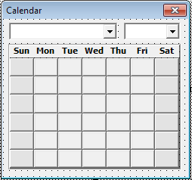

- frmCouseSelection
Description: Contains the Event Information Userform and related macros to properly execute its functionality.

Purpose: Used to collect information regarding the course event and input that information into the Dashboard worksheet.

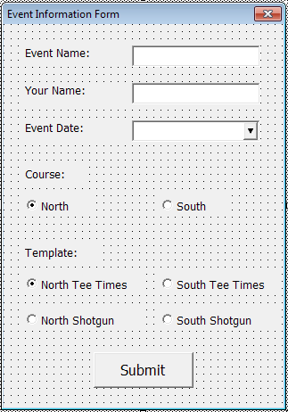

- frmImport
Description: Contains the Data Import Userform and related macros to properly execute its functionality.

Purpose: Used to manage the data importing process. This functionality includes hiding and un-hiding data import worksheets, clearing any information currently input within these worksheets, and finally, transferring the data from the worksheets to the backend PSS system for further processing.

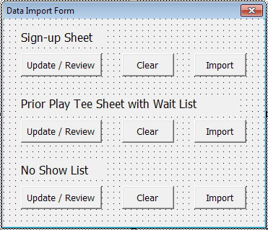
- frmManagePriority
Description: Contains the Priority Score Management Userform and related macros to properly execute its functionality.

Purpose: Used to manage all priority scores for the entire PSS system.

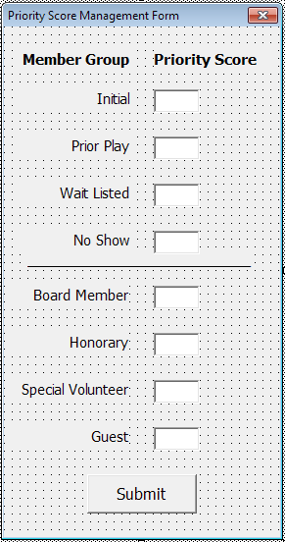

- frmUpdate
Description: Contains the Updating Userform.

Purpose: Used to notify the User that information is being processed while macros are running.

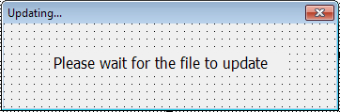

Modules Overview

- fcn_RandomGenerator
Description: Creates a random number function within Excel.

- mcr1_Settings
Description: Contains all general macros related to executive the PSS tool.

- mcr2a_inputListConversion
Description: Contains all macros related to the Sign-up Sheet Data Import process

- mcr2b_inputListConversion
Description: Contains all macros related to the Prior Play Tee Sheet with Wait List Data Import process

- mcr2c_inputListConversion
Description: Contains all macros related to the No Show List Data Import process

- mcr3_playerRandomGenerator
Description: Contains all macros related to calculating individual priority scores and individual ranks to determine if a player is Wait Listed

- mcr4a_grpNRandomNumberGenerator
Description: Contains all macros related to calculating group priority scores and group ranks for Assigned (non-Wait Listed) players in the North Course.

- mcr4a_grpSRandomNumberGenerator
Description: Contains all macros related to calculating group priority scores and group ranks for Assigned (non-Wait Listed) players in the South Course.

- mcr5_assignPlayers
Description: Transfers completed player and group assignments to the ‘Tee Sheet Priority’ and ‘Tee Sheet Ready’ worksheets.

- mcr6_TPP
Description: Populates the TPP Input sheet with information entered into the ‘Final Tee Sheet’ worksheet.

Woksheets Overview

- Welcome Page
Description: Default worksheet that appears when a User opens the PSS tool to explain how to properly open the file by enabled Editing, Content and Macros.

- input - signup
Description: Location where information for the course sign-up is entered by a User.

- input - prior play
Description: Location where information for the previous event Tee Sheet is entered by a User.

- input - no show
Description: Location where information for the latest no show list is entered by a User.

- Dashboard
Description: Main overview page that a User interacts with to use the PSS Tool.

- Map
Description: Contains reference information related to priority scores, entitled member lists and the number of allowable players for each course. Note: This worksheet includes numerous dynamic named ranges related to the information described above.

- player list – signup
Description: Contains a raw (unformatted) copy of the ‘input - signup’ worksheet and includes the primary player reference table for pre and post calculated priorities and ranks, assignment status and time preferences.

- player list - prior play
Description: Contains a raw (unformatted) copy of the ‘input - prior play’ worksheet.

- player list - no show
Description: Contains a raw (unformatted) copy of the ‘input – no show’ worksheet.

- pivot - signup
Description: Contains a pivot table of all players that signed up sorted in Ascending Order by their Total Priority Score, post prior play, no show or entitled status adjustments.

- calc - player priority
Description: Contains a raw (unformatted) copy of the ‘pivot – signup’ worksheet, along with formulas and pivot tables to rank all players in order of lowest (best) to highest (worst) priority score, using a random number generator to break any tied priority scores.

- pivot – groupNorth
Description: Contains a pivot table of all player groups post individual rank assignment for the North course, sorted in Ascending Order by their Total Priority Score.

- calc - groupNorth priority
Description: Contains a raw (unformatted) partial copy of the ‘pivot – groupNorth’ worksheet, along with formulas and pivot tables to rank all groups for the North course in order of lowest (best) to highest (worst) priority score, using a random number generator to break any tied priority scores.

- pivot – groupSouth
Description: Contains a pivot table of all player groups post individual rank assignment for the South course, sorted in Ascending Order by their Total Priority Score.

- calc - groupSouth priority
Description: Contains a raw (unformatted) partial copy of the ‘pivot – groupNorth’ worksheet, along with formulas and pivot tables to rank all groups for the South course in order of lowest (best) to highest (worst) priority score, using a random number generator to break any tied priority scores.

- pivot - tee sheet priority
Description: Contains pivot tables that display the information required for the ‘North Tee Sheet Priority’ and ‘South Tee Sheet Priority’ worksheets.

- North Tee Sheet Priority
Description: Contains a formatted copy of the first, North course, pivot table in the ‘pivot - tee sheet priority’ worksheet.

- South Tee Sheet Priority
Description: Contains a formatted copy of the second, South course, pivot table in the ‘pivot - tee sheet priority’ worksheet.

- pivot - north tee sheet ready
Description: Contains pivot tables and formulas that display the information for Assigned players required for the ‘North Tee Sheet Ready’ worksheet.

- pivot - north tee sheet ready 2
Description: Contains pivot tables and formulas that display the information for Wait Listed players required for the ‘North Tee Sheet Ready’ worksheet.

- North Tee Sheet Ready
Description: Contains a formatted partial copy of the Assigned players and Wait Listed players from the ‘pivot - north tee sheet ready’ and ‘pivot - north tee sheet ready 2’ worksheets, respectively.

- pivot - south tee sheet ready
Description: Contains pivot tables and formulas that display the information for Assigned players required for the ‘South Tee Sheet Ready’ worksheet.

- pivot - south tee sheet ready 2
Description: Contains pivot tables and formulas that display the information for Wait Listed players required for the ‘South Tee Sheet Ready’ worksheet.

- South Tee Sheet Ready
Description: Contains a formatted partial copy of the Assigned players and Wait Listed players from the ‘pivot - south tee sheet ready’ and ‘pivot - south tee sheet ready 2’ worksheets, respectively.

- tee sheet – assign
Description: Contains a raw copy of the North and South course tee times.

- North Tee Times Template
Description: Contains a blank formatted copy of the North Tee Times Template.

- South Tee Times Template
Description: Contains a blank formatted copy of the South Tee Times Template.

- North Shotgun Template
Description: Contains a blank formatted copy of the North Shotgun Template.

- South Shotgun Template
Description: Contains a blank formatted copy of the South Shotgun Template.

- Final Tee Sheet
Description: Contains a sample formatted copy of the Final Tee Sheet Template as an input to the ‘TPP Input’ worksheet.

- TPP Input
Description: Contains a formatted partial copy of the ‘Final Tee Sheet’ worksheet sorted by Group Number and Group Order.

